



DATABASE APPLICATIONS
(240)
STATE 2021

Production:
Job 1: Member Table __________ (100 points)
Job 2: Events Table __________ (100 points)
Job 3: Relationship Report __________ (150 points)
Job 4: Attendance Form __________ (100 points)
TOTAL POINTS __________ (450 points)

Test Time: 90 minutes

SCORING GUIDELINES
Unless indicated otherwise, student receives all points or none. | Points Possible | Points Earned
Job 1: Members Table
Correct field names and data types | 12
Data entry (3 points per record) | 48
Sorted in ascending order by Last Name | 10
Best fit columns and printed on one page landscaped | 15
Named Members xx-xxxx-xxxx | 15
Subtotal Job 1 | 100
Job 2: Events Table
Correct field names and data types | 23
Correct data entry (3 points per record) | 42
Best fit columns and printed on one page | 20
Named Sales xx-xxxx-xxxx | 15
Subtotal Job 2 | 100
Job 3: Table Query/Relationship Report
Created Attendance table | 25
Include correct fields | 15
Create Attended Yes/No field | 10
One to One relationships created | 20
Enforce Referential Integrity | 20
Printed with all tables full visible | 25
Printed on one page | 20
Named Relationships xx-xxxx-xxxx | 15
Subtotal Job 3 | 150
Job 4: Attendance Form/Subform
Create Attendance Form | 10
Include correct fields (2.5 pts each) | 20
Event Information is Primary Form | 20
Member Information is Subform | 20
Printed first record only on one page | 15
Named Attendance xx-xxxx-xxxx | 15
Subtotal Job 4 | 100
Total Points Earned | 450

JOB 1: MEMBERS TABLE
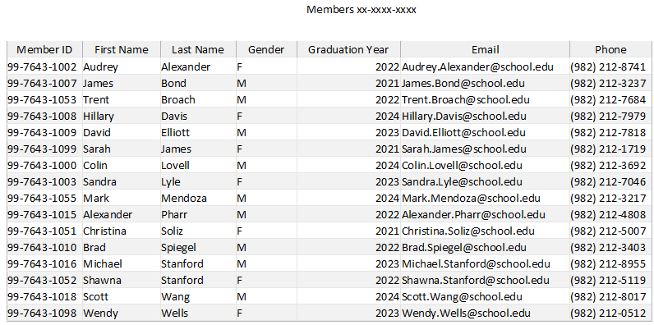
JOB 2: EVENTS TABLE
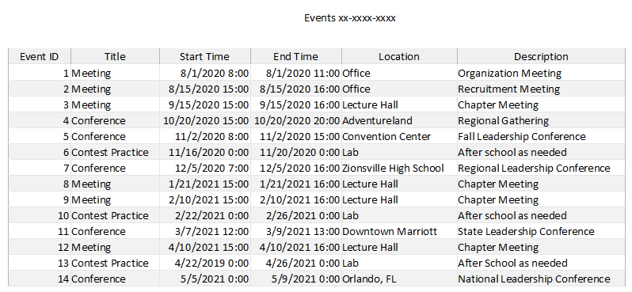

JOB 3: RELATIONSHIP REPORT
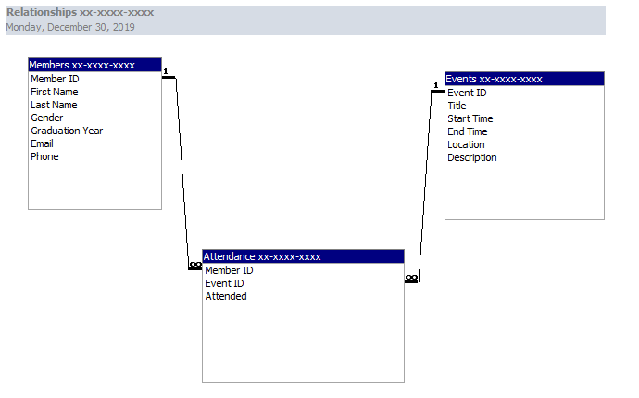
JOB 4: ATTENDANCE FORM/SUBFORM
